SIEM IN PRACTICE

LAB 01: INTRODUCTION TO SIEM
Internship: DG Interns HUB – Cybersecurity Internship
Platform: TryHackMe
Room Name: Introduction to SIEM
Category: Security Operations Center (SOC)
Topic: Security Information and Event Management

1. Objective
The main objective of this lab was to understand the fundamentals of Security Information and Event Management (SIEM) and how it is used in Security Operations Centers (SOC).
The lab focused on understanding how security logs are collected, monitored, analyzed and used to identify suspicious activities and potential cyberattacks.

Learning Objectives
- Understand the concept of SIEM.
- Learn the importance of log collection and monitoring.
- Understand SIEM architecture and components.
- Learn how security events are analyzed.
- Understand threat detection and alert generation.
- Learn how SIEM helps SOC analysts investigate security incidents.

2. Introduction to SIEM
SIEM stands for Security Information and Event Management.
It is a cybersecurity solution that collects, stores, monitors and analyzes security logs from multiple sources to identify suspicious activities and potential security threats.
SIEM provides centralized visibility into an organization's security environment.

Main Functions of SIEM
- Log Collection – Collects logs from different systems and devices.
- Log Aggregation – Combines logs into a centralized platform.
- Log Analysis – Analyzes collected security events.
- Event Correlation – Connects related events to identify suspicious patterns.
- Threat Detection – Identifies possible cyberattacks.
- Alert Generation – Generates alerts when suspicious activity is detected.
- Incident Investigation – Helps analysts investigate security incidents.

3. SIEM Architecture
SIEM architecture describes how security information moves from different sources into a centralized monitoring system.

Main Components
1. Log Sources
- Windows operating systems.
- Linux servers.
- Firewalls.
- Routers.
- Applications.
- Network devices.
2. Log Collection
Collects security events using agents, Syslog, APIs and other collection methods.
3. Log Processing
Converts raw log information into structured and understandable fields.
4. Event Correlation
Connects multiple related events to identify suspicious activities.
5. Alert Generation
Creates alerts when predefined security rules or detection conditions are matched.
6. Dashboard and Reporting
Displays security events, alerts and reports for SOC analysts.

SIEM Data Flow
Log Sources → Log Collection → Log Processing → Event Correlation → Threat Detection → Alert Generation → SOC Investigation.

4. Types of Security Logs
Security logs contain information about system activities and events.
Important log sources include:
Log Source | Information Collected
Windows Security Logs | Login attempts and account activities
Linux Authentication Logs | SSH login attempts and authentication events
Firewall Logs | Allowed and blocked network traffic
Application Logs | Application activities and errors
Network Logs | Network connections and traffic information
Sysmon Logs | Process creation and network activity

5. Importance of SIEM in SOC
A Security Operations Center uses SIEM to monitor and investigate security events.
Important benefits:
- Centralized security monitoring.
- Faster threat detection.
- Identification of suspicious login attempts.
- Detection of unusual network activities.
- Investigation of security incidents.
- Improved security visibility.
- Support for incident response.

6. Practical Understanding
During this lab, I studied how SIEM solutions help security teams monitor system activities and detect suspicious behaviour.
The following are examples of security activities that can be investigated using SIEM:
Example 1: Failed Login Attempts
If a user enters an incorrect password multiple times, SIEM can identify repeated authentication failures and generate a possible brute-force alert.
Example 2: Suspicious Network Activity
If an unknown IP address performs unusual network scanning, SIEM can analyze network logs and help identify suspicious connections.
Example 3: Unauthorized File Modification
If an important system file is modified unexpectedly, security monitoring tools can generate an alert for investigation.

7. Role of SIEM in Threat Detection
SIEM helps SOC analysts identify different types of security threats.

Threat | SIEM Detection
Brute-force attack | Repeated failed login attempts
Port scanning | Unusual connection attempts
Malware activity | Suspicious process and system events
Unauthorized access | Unusual authentication activity
Privilege escalation | Suspicious account privilege changes

8. Challenges Faced
- Understanding how SIEM collects logs from different sources.
- Understanding the relationship between raw logs and security alerts.
- Learning how event correlation helps identify suspicious activities.
- Understanding how SOC analysts investigate security events.
I addressed these challenges by reviewing the lab material, studying the SIEM workflow and understanding practical security event examples.

9. Key Learning Outcomes
After completing this lab, I learned:
- SIEM is used for centralized security monitoring.
- Logs are important for detecting suspicious activities.
- Event correlation helps identify possible attacks.
- Security alerts help SOC analysts investigate incidents.
- SIEM improves threat visibility and incident response.
- SOC analysts use SIEM to monitor and protect organizational systems.

10. Screenshots and Evidence
TryHackMe Introduction to SIEM room completion.
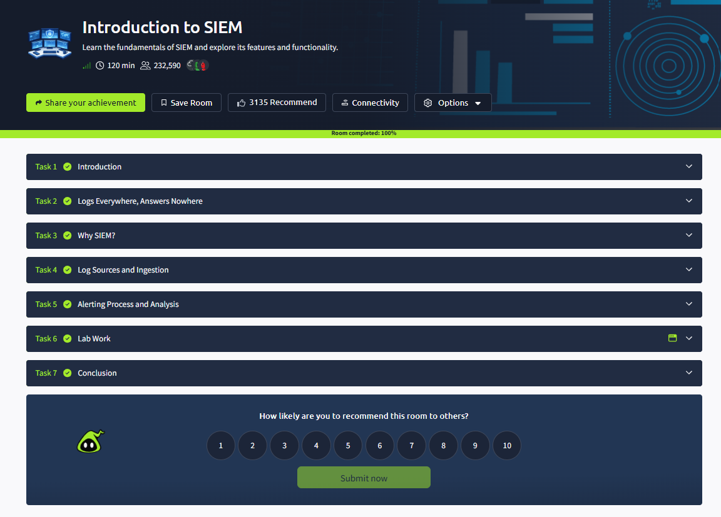

11. Conclusion
I successfully completed the TryHackMe Introduction to SIEM lab.
This lab helped me understand the fundamentals of SIEM, its architecture, log collection, security monitoring and threat detection.
I also learned how SIEM supports SOC analysts by providing centralized security information, generating alerts and helping investigate suspicious activities.
This knowledge will help me in upcoming practical tasks involving Splunk, Wazuh, log ingestion and security alert investigation.

